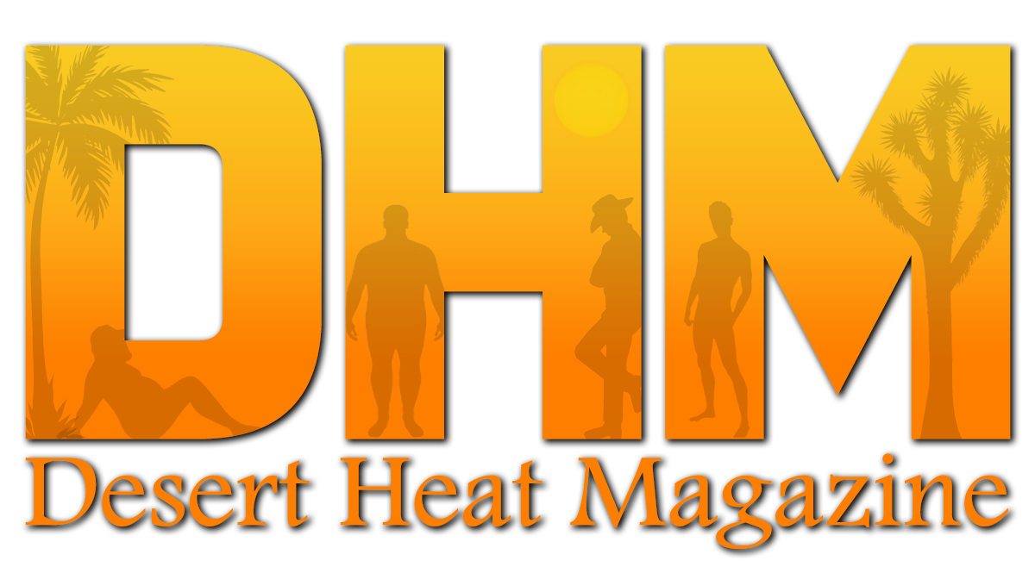
Image Release Form and Credits
By filling out this release form, I (Name Listed Below) hereby grant Desert Heat Magazine permission to use the photography submitted in their publication, including their website & internet postings. I verify that I have the right to publish the people in the pictures and that I own the rights to have these pictures distributed, published, or otherwise promoted by Desert Heat Magazine, or their subsidiaries, as they see fit for their publication. I certify that this work of art is not plagiarized from another source.
I understand that the picture(s) I submit to Desert Heat Magazine may be used in their publication in print or digitally, as well as on their website, and other internet postings.
I understand that my completing this form only allows Desert Heat Magazine to use my photos in their publication, and at no time will Desert Heat Magazine assume rights to the photos themselves, other than me allowing them the right to publish the photos submitted and should they then post pages from the publication on their website or in internet postings.
I understand that at no time shall I be paid, reimbursed, compensated, or given royalties, now or at any point in the future by Desert Heat Magazine.
I hereby irrevocably authorize Desert Heat Magazine to copy, exhibit, publish or distribute these photos in their publication for purposes of publicizing Desert Heat Magazine in their publication, website, or internet postings or for any other lawful purpose.
I hereby hold harmless and release and forever discharge Desert Heat Magazine, and it's subsidiaries, from all claims, demands, and causes of action which I, my heirs, representatives, executors, administrators, or any other persons acting on my behalf or on the behalf of my estate have or may have by reason of this authorization.
I certify that the person or ALL person(s) in the photo(s) are at least 18 years of age. I have read this release and I fully understand the contents, meaning, and impact of this release.

I affirm that all given statements to the magazine are true. As the provider, I also understand that a submission of content, or completion of release, is not a guarantee of publication. If Work is published, it is the duty of the provider (and not Desert Heat Magazine) to notify all involved parties of their involvement in the final product.
* This information will not be published (unless otherwise noted)

Photographer Information:
* Legal Name:
* Alias/Business Name:
* Address:
* Contact Phone:
* Email:
* Social Media Links:

Set Information:
Set title (Title of feature, if applicable):
Credits as they will appear in the publication (Photographer credited for images):

Model Information:
(If the Model wants their social media links and/or email address provided with the images, please provide below. If not, please leave blank. If more than one model is used, please copy and paste the below fields to create set for each model)
Model name (Stage name):
Model's email address:
Model's social media Links:
Twitter:
Instagram:
Tumblr:
Facebook:
Other:

